
ANKARA YILDIRIM BEYAZIT UNIVERSITY SCHOOL OF ENGINEERING AND NATURAL SCIENCES

Optimization of Rainwater-Integrated Water Tank Locations for Forest Fire Response

B. Sc Thesis by
Pakize Nur YILMAZ
Mert EYÜBOĞLU
Alperen ÖNCEL

Advisor
İbrahim YILMAZ , Assoc. Prof.
Ahmet Süha HANCIOĞLU, Res. Asst.
Department of Industrial Engineering

January, 2026
Optimization of Rainwater-Integrated Water Tank Locations for Forest Fire Response

A Thesis Submitted to the School of Engineering and Natural Sciences of
Ankara Yıldırım Beyazıt University.
In Partial Fulfillment of the Requirements for the Degree of Bachelor of Science of Philosophy in Industrial Engineering, Department of Industrial Engineering

by
Pakize Nur YILMAZ
Mert EYÜBOĞLU
Alperen ÖNCEL

Advisor
İbrahim YILMAZ , Assoc. Prof.
Ahmet Süha HANCIOĞLU, Res. Asst.
Department of Industrial Engineering

January, 2026

ETHICAL DECLARATION

In this thesis study, which was prepared in accordance with the Ankara Yıldırım Beyazıt University
School of Engineering and Natural Sciences Thesis Writing Rules, we declare that
• All data, information and documents presented in this thesis have been obtained within the framework of academic and ethical rules,
• All information, documents, evaluations and results are presented in accordance with scientific ethics and academic integrity,
• All sources and studies used in this thesis have been properly cited and referenced,
• No changes or manipulations have been made to the data used,
• The work presented in this thesis is original.
Otherwise, we declare that we accept all legal and academic responsibilities that may arise.

ACKNOWLEDGEMENTS

We would like to express our sincere gratitude to our supervisor, Assoc. Prof. İbrahim YILMAZ and Res. Asst. Ahmet Süha Hancıoğlu, for his valuable guidance, constructive feedback, and continuous support throughout this study. His academic insight and helpful suggestions significantly contributed to the successful completion of this thesis.

We also thank Ankara Yıldırım Beyazıt University for providing the academic
environment and resources that made this research possible.

January, 2026
Pakize Nur YILMAZ
Mert EYÜBOĞLU
Alperen ÖNCEL

CONTENTS
- ABSTRACT ............................................................................................................. 8
- INTRODUCTION ................................................................................................... 10
- LITERATURE REVIEW ......................................................................................... 12
- PROBLEM DEFINATION........................................................................................ 32
- MATHEMATICAL MODEL FOR THE PROBLEM .............................................. 33
3.1. Sets Parameters and Decesion Variables ................................................... 33-34
3.2. Mathematical Model .................................................................................. 35-37
- CONCLUSION...................................................................................................... 38
- FUTURE GOALS ................................................................................................. 39
- REFERENCES ..................................................................................................... 40

FIGURE LIST
Figure 1 ……………………………………………………………………………………..11
Figure 2 ……………………………………………………………………………………...23
Figure 3 ……………………………………………………………………………………...25
Figure 4 ……………………………………………………………………………………...28
Figure 5 ……………………………………………………………………………………...29
Figure 6 ……………………………………………………………………………………...30
TABLE
Table 1 ……………………………………………………………………………………...14
Table 2 ……………………………………………………………………………………...31
ABSTRACT
Today, forest fires are not only ecological disasters but also represent large-scale natural hazards that directly affect many areas such as the economy, public health, and biological systems. Due to reduced precipitation, significant decreases in humidity levels, increased intensity of westerly winds, and various atmospheric dynamics, multiple environmental parameters not only accelerate the spread rate of forest fire risk but also significantly affect its seasonal duration and geographical distribution. These factors critically increase the difficulties in intervention and, consequently, the number of areas exposed to fire.
Turkey, located in the humid Mediterranean climate zone, is experiencing prolonged dry periods, causing the months with high fire risk to start earlier and end later. As a result, the country faces a forest fire threat whose frequency increases exponentially each year, leading to adverse impacts on climate through carbon emissions and major economic losses in the agricultural and tourism sectors due to its geographical characteristics.
The most critical factor in forest fire response is completing the intervention in the shortest possible time. The duration of intervention largely depends on the proximity of the fire area to water sources. Therefore, access to water resources used in firefighting areas is a critically prioritized problem. The locations where water tanks should be positioned around forest areas depend not only on geographical distance but also on criteria such as fire risk density, travel time, water capacity, and geological and infrastructural conditions. Properly located water tanks play a decisive role in controlling fire spread by reducing the response time of firefighting teams.
A review of the literature shows that existing studies have focused on strategic positioning of firefighting teams, personnel selection and allocation, optimal route determination, and base selection for deployed aerial vehicles in order to reduce response time. However, limited attention has been given to the replenishment structure of water used in firefighting, as well as to ponds and site selection of water reservoirs. Existing studies generally treat water sources as fixed parameters in firefighting operations. It has been observed that these studies are insufficient in holistically addressing the location, capacity, renewability, and spatial planning of water tanks.
This study aims to develop a mathematical model that holistically considers multiple parameters in determining the locations of water tanks to be established for improving forest fire response processes, one of the most critical environmental problems. By addressing this gap, the mathematical model directly incorporates water supply infrastructure into the optimization framework and integrates the interaction between time, cost, and environmental sustainability in forest fire management within a single model. The model offers an environmentally friendly solution by enabling the collection of rainwater throughout the year, reducing water transportation costs from external sources, and avoiding damage to forest habitats. Compared to existing systems, the developed model is expected to achieve a 20–25% increase in operational efficiency and up to a 30% reduction in external water demand through rainwater integration. Thus, the results present a smart, environmentally friendly, and decision-support-based system proposal that can be used in fire management strategies. In this respect, the study makes an innovative and original contribution to both engineering-based disaster management models and the sustainable resource planning literature.
Keywords: Forest fires, Geographical location analysis, Rainwater integration, Candidate facility selection model, Response time optimization

INTRODUCTION
Forest fires have become one of the most destructive environmental disasters in recent years, posing serious threats not only to natural ecosystems but also to human life, economic stability, and biological diversity. Rising temperatures due to climate change, prolonged drought periods, low humidity levels, and intensifying wind conditions have significantly increased both the frequency and the spread rate of forest fires. Countries located in the Mediterranean climate zone, such as Turkey, are particularly vulnerable to these risks due to the extension of fire seasons and the increase in large-scale fire events.
Forests are of vital importance for climate regulation, biodiversity conservation, soil quality sustainability, and the continuity of the water cycle. In addition to their ecological roles, forests make significant contributions to socioeconomic development through forestry activities, tourism, and employment. Therefore, forest fires lead not only to environmental losses but also to multidimensional consequences such as economic damage, disruption of local livelihoods, and long-term rehabilitation costs. In particular, the large-scale fires experienced in Turkey after 2020 have raised serious questions regarding the effectiveness of existing firefighting systems.
One of the most critical factors in reducing the damage caused by forest fires is rapid and effective intervention. Scientific studies indicate that fires that are not brought under control within the initial minutes grow geometrically, making the suppression process increasingly difficult. In this context, access to water plays a vital role in firefighting operations. However, in many forested and mountainous regions, insufficient water resources, challenging topography, and infrastructure deficiencies significantly prolong response times. The need for firefighting teams to travel long distances for water replenishment reduces operational efficiency and increases the risk of fire spread.
The majority of studies in the literature on forest fire management focus on issues such as the location of fire stations, allocation of teams and vehicles, route optimization, and positioning of aerial firefighting assets. While these studies provide important contributions to operational planning, the water supply infrastructure used in firefighting—particularly the placement and capacity planning of water tanks—has generally been treated as a fixed element. Studies that directly consider water tanks as decision variables and examine this infrastructure within a holistic optimization framework are limited.
This thesis aims to fill this gap by proposing an optimization approach for the strategic placement of water tanks used in forest fire response. In the study, water tanks are treated as direct decision variables, and multiple criteria—such as fire risk intensity, response time thresholds, road accessibility, terrain slope, distance to residential areas, and environmental protection constraints—are integrated within a single mathematical model. In addition, the model incorporates rainwater harvesting systems into the water supply infrastructure to provide a sustainable solution.
Rainwater harvesting offers an environmentally friendly and renewable solution for strengthening firefighting infrastructure, especially in regions experiencing seasonal water scarcity. The storage of rainwater collected throughout the year at strategic locations creates a reliable water reserve during periods of high fire risk. This approach reduces the need for transporting water from external sources, thereby lowering operational costs and contributing to environmental sustainability.
The main objective of this study is to develop a mathematical optimization model that enables the optimal placement of water tanks used in forest fire management under conditions of minimum response time, coverage of high-risk areas, and compliance with environmental and logistical constraints. By combining geographic information system–based spatial analyses with optimization techniques, this approach aims to strengthen decision-making processes in disaster management, enhance the effectiveness of fire response, and contribute to sustainable infrastructure planning.
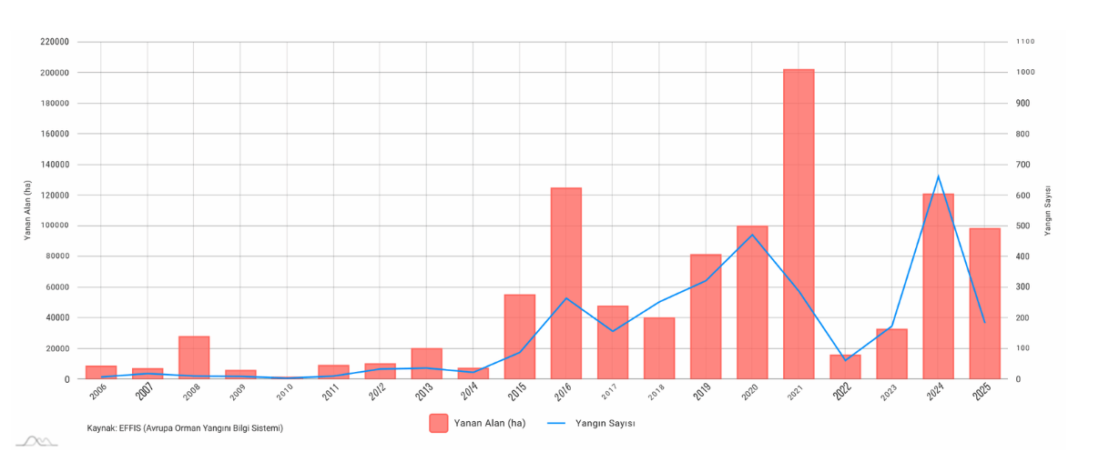
Figure 1: Trend of forest areas affected by wildfires in Türkiye

2.LITERATURE REVIEW
Forests are among the most important natural resources of our country, not only because they maintain ecological balance, prevent air pollution, regulate the water cycle, positively affect climate structure and diversity, prevent natural disasters such as erosion and landslides, and host many endemic species, but also because they meet society’s demand for forest products. Forests act as carbon sinks that mitigate climate change, regulate temperatures, and ensure the continuity of water resources by stabilizing precipitation cycles [1]. In addition, forests play a fundamental role in the conservation of biological diversity; beyond serving as habitats for hundreds of thousands of species, they strengthen the organic structure of soil and contribute to ecosystem productivity as well as economically important activities such as agriculture [2]. From a socioeconomic perspective, forests create employment for many individuals through the production of timber and non-timber products, support economic development, and directly contribute to societal progress [3]. Therefore, the sustainable management of forests stands out not merely as an environmental necessity but also as a prerequisite for economic and social development.
Rising temperatures, extreme weather events, and prolonged droughts caused by global climate change—together with the notable increase in fires of unknown origin, with more than half of all fires now recorded as “undetermined”—have become the main factors increasing both the severity and the spread rate of forest fires [4]. Globally, it has been reported that the average annual burned area due to forest fires has increased by more than 30% over the past 20 years, with this increase occurring much more rapidly in fire-prone ecosystems such as the Mediterranean region and, more recently, Australia, Canada, and California [5]. Due to its geographical location, Turkey is also a high-risk country in terms of forest fires, with the fire season starting earlier and ending later each year. This situation adversely affects countries economically as well, particularly due to seasonality effects. According to General Directorate of Forestry (OGM) statistics, the average annual number of fires increased by 92% between 2008 and 2024, and the Manavgat and Marmaris fires of 2021 were recorded among the largest forest fire disasters in Turkey’s history [6]. In these fires, more than 100,000 hectares of forest land were destroyed, over 10,000 people were evacuated, and residential areas suffered severe damage [7].
As a result of fires, not only forests are damaged; flora, wildlife, water resources, soil, climate, recreational areas used by people, as well as settlements near and around forested areas are also affected. Compensating for these damages is a long process that begins with preventive and protective measures before the fire, continues with firefighting during the event, and extends to the costs of post-fire damage, occupying a significant share of national economies. In conclusion, fire having influenced ecosystems for approximately 400 million yearspossesses not only ecological effects but also substantial socio-economic impacts that cannot be ignored [8]. These multidimensional impacts of forest fires on ecosystems and the economy once again highlight the strategic importance of fire prevention and response policies.
In this context, early and effective fire response capacity emerges as one of the most critical factors determining the magnitude of damage. Scientific studies show that when fires are not brought under control within the first minutes, fire behavior shifts toward geometric growth [9]. As response is delayed, the likelihood of fires spreading from rural areas to forest–settlement interfaces increases, rapidly putting human life, property, and biological species at risk [10]. However, one of the major challenges in firefighting efforts in Turkey is the accessibility and speed of access to water for firefighting teams. The mountainous, rugged, and hard-to-access geographical structure of regions where forest fires most commonly occur significantly prolongs teams’ access times to water and reduces intervention effectiveness. In particular, the limited water-carrying capacity of fire trucks forces teams to frequently undertake long-distance water replenishment when adequate water infrastructure is not available near the fire area. This situation leads to both time loss and an increased risk of fire growth.
Operating under these physical and infrastructural challenges results in reduced suppression performance, equipment wear, and human resource losses for firefighting teams. In Turkey’s ecologically high-risk forest fire regions, terrain slope and vegetation characteristics, the distribution of water resources, and logistical capacity deficiencies directly affect fire control durations [6,7]. Therefore, strengthening firefighting infrastructure, strategically locating water resources, and considering terrain structure are of great importance in this regard [9,11].
These inadequacies in firefighting infrastructure become even more dangerous, particularly along the Mediterranean coastal belt where population is increasing and agriculture and tourism are intensifying. In areas where the regional population increases by at least three times during the tourism season, fires have the potential to turn into social and economic crises. For this reason, the strategic placement of water tanks plays a life-saving role in disaster management. Although numerous models have been developed in the existing literature regarding fire stations, routes, and team allocation, studies on the site selection of water supply infrastructure (water tanks, ponds, reservoirs) remain quite limited. In Turkey, research on this topic is mostly confined to post-fire analyses or assessments of existing infrastructure efficiency [12]. However, according to OGM data, in 40% of large forest fires that occurred between 2019 and 2024, the primary factor prolonging initial response time was the absence of a usable water tank near the fire site [6]. This clearly demonstrates the necessity of spatial planning based on the capacity, accessibility, and strategic distribution of water tanks.
Accordingly, this study aims to fill this gap in the literature by developing a scientific decision-support model for the optimal placement of water tanks in forest fire management. The underdeveloped state of firefighting infrastructure becomes particularly hazardous along the developing Mediterranean coastline, where population is steadily increasing and agriculture and tourism are concentrated. In these areas, where the regional population at least doubles during the tourism season, fires pose the potential to evolve not only into ecological but also social, economic, and demographic crises. Therefore, the strategic and terrain-appropriate placement of water tanks plays a crucial, life-saving role in disaster management.

Table 1:Selected studies in the literature on forest fires and forest fire management
AUTHOR(S) | YEAR | PROJECT | CONTENT
Haight, F. A., & Fried, D. | 2007 | A model for optimizing the placement of fire fighting vehicles and crews. | Integer Linear Programming model based on the Maximal Covering Location Problem to optimize the placement of firefighting crews within a predefined time.
Renkas | 2022 | Optimizing fire station locations to improve response time and firefighting effectiveness | GIS-based Linear Programming approach, specifically the P-Median model, to minimize total travel distance and optimize the locations of fire stations for enhanced response effectiveness.
Akay, D., Aydın, M., & Toprak, B. | 2011 | Optimizing routes between fire stations and potential fire locations using GIS-based decision support system. | GIS-based Decision Support System using Dijkstra’s Algorithm to optimize vehicle routing by considering terrain slope and forest road conditions to minimize response time.
Thompson, A., Ellis, S., & Williams, J. | 2014 | A large-scale wildfire suppression model: Optimizing aircraft station locations for fire fighting efficiency | Mixed Integer Linear Programming (MILP) model to optimize the location of aircraft stations, focusing on minimizing travel time and fleet operational costs for large-scale wildfire suppression.
US Forest Service | 2019 | Operational standards for the positioning of aerial firefighting resources. | Operational Standards and Rule-Based Guidelines for positioning aerial resources, focusing on safety protocols and maximum response time thresholds for wildfire suppression.
Holuša, M., & Novak, M. | 2021 | Evaluation of water supply infrastructure for wildfire suppression: Capacity and accessibility analysis | Spatial and Capacity Analysis to evaluate the effectiveness of existing water supply infrastructure, emphasizing the impact of terrain accessibility and seasonal water availability on firefighting operations.

Existing studies have addressed the determination of the locations of firefighting resources and rapid response to fire zones, and models have been developed on this basis, including station location and coverage optimization [13, 14], GIS-based safe route and accessibility analyses [15, 16], and the placement of aircraft fleets (LATs) with availability–speed and capacity trade-offs [17]. While this line of research provides an important foundation, water supply infrastructure has mostly been treated as a fixed input; the decision of which water tanks should be established, where, and with what capacity has not itself been formulated as an optimization problem. Contributions related to water points have largely remained at the inventory or adequacy assessment level [18, 19]. This study directly targets this gap in the literature.
The proposed framework not only incorporates water tanks as decision variables in the model but also explicitly considers geographical constraints. It integrates indicators such as response time (first 10–15 minutes), capacity and replenishment cycle, road slope and accessibility, wildland–urban interface (WUI) risks, tourism intensity, and fire hazard indices into a multi-criteria objective function [18]. In this way, the optimal placement and network-level strategic distribution of water tanks are addressed systematically for the first time. Accordingly, this study aims to fill this significant gap in the literature by developing a scientific decision-support model for the optimal placement of water tanks in forest fire management. The development of such a model will not only contribute to reducing firefighting response times but will also provide undeniable benefits for sustainable disaster management in terms of human life, ecosystem integrity, and economic losses [9].
A review of the literature reveals a substantial gap in the strategic planning of water supply infrastructure, the integration of capacity and accessibility within a multi-criteria decision model, and the evaluation of rainwater harvesting within the framework of sustainable disaster management. One of the aspects that increases the originality of this study is that it not only focuses on optimally locating water tanks to be constructed, but also emphasizes the sustainable use of water within a cyclical system while comprehensively addressing cost effectiveness. Most studies in the literature are based on planning the number of emergency response teams and the utilization of vehicle bases for firefighting [13], and remain limited in holistically addressing how water resources are obtained and their environmental impacts.
In contrast, this study highlights an innovative solution in which the water tanks to be located collect rainwater accumulated throughout the year and store it according to periods of increased forest fire occurrence, thereby contributing significantly to cost minimization. In this way, high-cost practices such as transporting water from external sources or long-distance hauling are minimized, and the system establishes a closed water cycle. The storage of rainwater in tanks reduces water imbalances depending on regional climatic conditions and helps maintain tank capacity and fill rates at feasible levels. The system is strengthened with environmental constraints that ensure water tanks are located in a manner that does not harm forest areas, damage vegetation cover or the habitats of living organisms, or disrupt natural soil structure. In this respect, the study presents an integrated approach that combines engineering optimization with principles of sustainable development.
As a result of this study, an innovative and sustainable mathematical decision-support model will be introduced, enabling forest fire response processes to be managed more effectively from both operational and environmental perspectives. The developed model will not only shorten the response time of firefighting teams but will also enable the strategic, efficient, and environmentally sensitive use of water resources. Upon completion of the study, detailed spatial maps indicating optimal water tank locations will be produced for high-risk areas, particularly in Turkey’s Mediterranean and Aegean regions, which are most exposed to forest fires. These maps will allow decision-makers (such as the General Directorate of Forestry, AFAD, and municipalities) to conduct pre-fire planning on a more scientific basis and will clearly identify areas where new tank construction is required.
Furthermore, the developed model will operate in an integrated manner with rainwater harvesting systems, enabling precipitation collected throughout the year to be stored and used for firefighting during the summer months. As a result, the need to transport water from external sources will be significantly reduced, fuel and labor costs will decrease, and operational processes will become more economical. Tank capacities will be optimized based on multidimensional parameters such as seasonal precipitation amounts, slope, accessibility, population density, and fire risk maps. Thus, each tank will be located in the most appropriate manner from environmental, logistical, and economic perspectives. In the long term, the project outputs can be integrated into national disaster management policies, increasing Turkey’s resilience to forest fires and redefining resource management in a sustainable way. In this respect, the project is presented not merely as a mathematical model for forest fire management, but as a comprehensive system that integrates rainwater harvesting and cost parameters into a unified framework.

2.1 Location Selection Models
In the fight against forest fires, water supply infrastructure is considered a critical component in terms of the effectiveness and speed of response. Despite this importance, for many years in the fire management literature, water resources have mostly been treated as fixed or exogenous elements, and the placement of water reservoirs and water tanks has been examined as a direct decision problem in only a limited number of studies. In recent years, however, studies have begun to address this deficiency by considering water reservoir location selection as one of the fundamental components of fire management [20]. Studies focusing on the strategic location selection of water reservoirs for forest fires have demonstrated that reservoir placement has a direct impact on fire response time. In these studies, reservoirs were treated as discrete facilities, and a coverage-based approach was adopted to ensure access to high-risk fire areas within a specified response time. The findings emphasized that accessibility criteria calculated over the road network play a decisive role in reservoir location decisions and that geographical proximity alone is not a sufficient criterion. The results indicate that even a limited number of reservoirs, if properly located, can significantly increase the effectiveness of firefighting operations.
Approaching reservoir location selection from a multi-criteria perspective, [21] proposed a model for sustainable fire prevention planning in forest ecosystems within the Mediterranean climate zone. In this study, the reservoir location problem was addressed by jointly evaluating multiple criteria such as fire risk, accessibility to the road network, topographic suitability, and environmental sustainability. By integrating multi-criteria decision-making methods with optimization approaches, the study demonstrated that reservoir locations should be evaluated not only in terms of operational efficiency but also with respect to long-term environmental impacts. The results revealed that poorly located reservoirs fail to deliver the expected benefits in firefighting and lead to inefficient resource utilization.
A study that directly examined the operational impact of water supply infrastructure in firefighting operations emphasized that water replenishment points play a critical role in fire suppression models [22]. The study showed that delays in accessing water replenishment points limit the operational capacity of firefighting teams and prolong the time required to bring fires under control. It argued that the locations of water replenishment points directly affect task assignments and response routes of firefighting resources, and therefore water supply infrastructure should be treated as a dynamic decision variable rather than a fixed element in fire management models.
The common findings of these three studies indicate that the placement of water reservoirs and water tanks has a decisive impact on response time, operational efficiency, and fire control success in forest fire management. The literature suggests that location decisions for water supply infrastructure should be integrated with fire risk distribution and transportation network structure. Moreover, the use of multi-criteria approaches allows reservoir location problems to be evaluated not only for short-term operational benefits but also in line with long-term sustainability objectives.
In this context, although existing studies show that reservoir location selection is gaining importance in the fire management literature, application-oriented studies remain limited, especially in high-risk countries such as Turkey. Building upon the approaches proposed in the literature, this thesis addresses the location selection of water tanks for forest fires as a coverage- and accessibility-based optimization problem and aims to develop a decision-support model that accounts for local conditions.

2.2 Resource Planning and Response Optimization Studies in Forest Fires
Effective planning of resources in forest fire management is critically important for controlling fires at an early stage. Accordingly, the number of studies addressing preparedness and response processes through mathematical models has been increasing in the literature. The common objective of these studies is to ensure the most effective spatial positioning and allocation of limited firefighting resources [23]. In their spatial optimization model for resource allocation in forest fires, fire risk distribution and response time constraints were jointly considered. The placement of firefighting resources and task assignments were modeled to minimize total risk loss. The authors demonstrated that fire risk exhibits spatial heterogeneity, and therefore random or uniform resource distribution reduces operational efficiency. Model results showed that strategically locating resources in high-risk areas reduces response delays and significantly lowers potential fire damage. This study is regarded as one of the foundational works highlighting the effectiveness of spatial optimization approaches in fire management.
Addressing resource planning in firefighting through a simulation-based approach, [24] evaluated the spatial planning of fire stations and response units. The performance of firefighting operations under different station placement scenarios was analyzed through simulation. The findings indicate that the spatial distribution of stations has a decisive impact on response time and operational success. The authors argued that static solutions based solely on optimization models are insufficient and that simulation-supported approaches better reflect the dynamic nature of fires. In this respect, the study demonstrates that combining spatial optimization and simulation methods provides more realistic decision support in fire management.
In a more recent study, [25] addressed fire resource planning directly within an integer programming framework. In this study, location selection and allocation decisions for firefighting resources were modeled as a mathematically exact optimization problem. The authors emphasized that integer programming offers a powerful tool for producing optimal solutions under resource constraints and operational requirements. The results showed that mathematically optimized solutions yield more balanced and effective outcomes compared to heuristic or experience-based approaches.
When these three studies are evaluated together, it becomes clear that resource planning in forest fire management is not merely an operational issue but a strategic problem that must be addressed spatially and mathematically. Optimization- and simulation-based models in the literature provide significant contributions in reducing response time, prioritizing high-risk areas, and efficiently utilizing limited resources. However, it is noteworthy that in most of these studies, water supply infrastructure is generally treated as a fixed element and is not modeled as a direct decision variable. This creates a significant research gap for studies focusing on the location selection of water tanks and water replenishment points.

2.3 Infrastructure Resilience in Forest Fire Management
In the forest fire management literature, most studies aimed at increasing response capacity focus on the placement of firefighting teams, stations, and vehicles. Recent studies have revealed that fires not only affect natural ecosystems but also directly impact critical infrastructure systems—such as water supply infrastructure, transportation networks, and energy systems—and that the loss of functionality in these infrastructures severely limits fire response capacity [26, 27]. In this context, it is emphasized that fire management should be addressed not only from a rapid response perspective but also within the framework of infrastructure resilience.
The concept of infrastructure resilience refers to a system’s capacity for pre-disaster preparedness, performance during a disaster, and post-disaster recovery. [27] demonstrated that water, transportation, and energy infrastructures exhibit interconnected structures during fires, and damage to one system can cascade to others. In particular, damage to or loss of functionality in water supply infrastructure directly reduces the effectiveness of firefighting operations and prolongs response times. These findings indicate that infrastructure should be considered not merely as a supporting element but as a critical decision component in fire management.
Studies focusing on the impacts of fires on water infrastructure show that post-fire periods may involve water quality degradation, pressure losses, pipeline damage, and long-term service interruptions [26]. By examining the effects of forest fires on water systems within the framework of cascading impacts, these studies reveal that fires can cause multi-stage and long-term problems in water infrastructure. They emphasize that restricted access to water during and after fires poses serious risks not only to public health but also to the sustainability of firefighting operations.
The resilience of transportation networks also plays a critical role in fire management. Road closures, damage, or inaccessibility during or after fires delay the arrival of firefighting teams and water supply vehicles to response areas. [28] analyzed post-fire recovery processes of road networks and demonstrated that vulnerabilities in transportation infrastructure have a decisive impact on response time. These findings suggest that fire management planning should consider not only the current condition of road networks but also potential disruption scenarios.
Despite these findings, the literature contains limited studies that integrate facility location models with infrastructure resilience concepts. Most facility location studies assume continuous accessibility of transportation networks and uninterrupted operation of water supply infrastructure. Such assumptions fail to adequately reflect infrastructure failures and access constraints that may arise during fires in high-risk regions [29]. In their study on emergency facility location, [29] proposed the concept of backup coverage, arguing that dependence on a single facility or access route poses risks to service continuity. This approach provides an important theoretical framework for linking infrastructure resilience with spatial planning in fire management.
More recent studies focusing on the spatial planning of water supply infrastructure highlight the importance of integrating resilience perspectives into fire prevention and response planning. [30] addressed the location selection of water reservoirs for forest fires within the framework of sustainability and accessibility criteria, showing that the availability of alternative water sources in high-risk areas increases response capacity. The study emphasized that water tanks should be considered not only as coverage-providing elements but also as redundancy mechanisms against infrastructure failures.
Taken together, these studies indicate that although the literature contains important findings regarding infrastructure resilience in fire management, these findings are often addressed in a fragmented manner. Studies that integrate water supply infrastructure, transportation network vulnerability, and spatial location decisions remain limited. This thesis aims to address this gap by considering the location selection of water tanks for forest fires not only in terms of coverage and response time but also from the perspective of infrastructure resilience and redundancy. In this respect, the study seeks to provide an integrated contribution to the literature on the spatial planning of water supply infrastructure in forest fire management.
In the existing literature, studies on forest fire management predominantly focus on the placement of fire stations, response teams, and vehicles, while water supply infrastructure and transportation networks are generally assumed to be fixed and continuously operational elements. However, recent studies show that forest fires can cause serious damage to water supply infrastructure and transportation networks, and that vulnerabilities in these systems directly constrain fire response capacity [26, 27, 28]. Nevertheless, studies that integrate facility location models with infrastructure resilience concepts remain limited. In particular, the evaluation of water tank location selection not only in terms of coverage and response time but also from the perspective of redundancy and service continuity against infrastructure failures represents a significant gap in the literature.
2.4 Examination of the Geographical, Ecological, and Infrastructural Characteristics of Regions with High Forest Fire Concentration in Turkey
Forest fires in Turkey do not exhibit a spatially homogeneous distribution; instead, they show a pronounced concentration tendency in certain regions. Spatial and temporal analyses conducted across Turkey reveal that forest fires are particularly clustered in the Mediterranean, Aegean, and Southern Marmara regions [31]. These regions carry a higher risk in terms of fire ignition and spread due to their climatic conditions, vegetation structure, and topographic characteristics.
2.4.1 Fire Density and Spatial Distribution Across Turkey
GIS-based studies conducted at the national scale indicate that a large proportion of fire incidents occur in forested areas located within the Mediterranean climate zone [32]. In these regions, high summer temperatures, low relative humidity, and wind effects increase both the likelihood of fire ignition and the rapid spread of fires. Analyses of the spatial distribution of fires demonstrate that fire incidents are not isolated or random events, but rather are concentrated in areas associated with specific geographical characteristics.
These findings indicate that fire risk is closely related not only to meteorological factors but also to terrain structure, forest type, and human activities. Therefore, fire management planning should be addressed through a holistic approach that takes into account the national-scale distribution of risk.

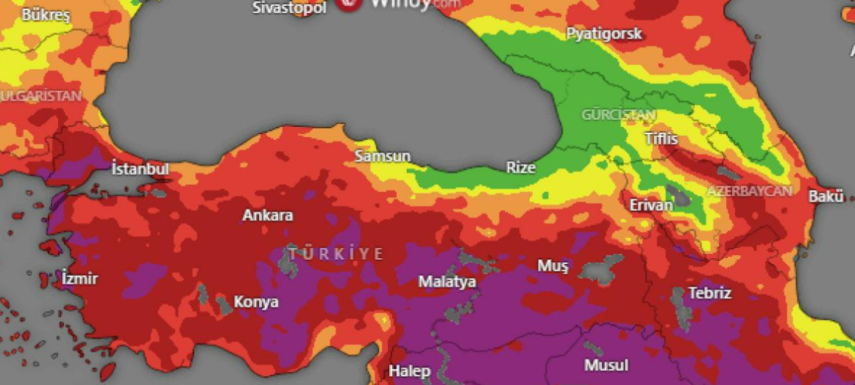
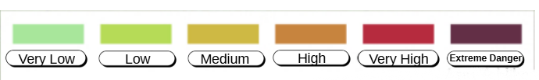
Figure 2: Heat–frequency intensity map of Türkiye

2.4.2 Topographic Characteristics: Slope, Ruggedness, and Accessibility
Topography emerges as a significant determining factor in regions where fires are concentrated. In Turkey, particularly in the Mediterranean and Aegean regions, a large proportion of forested areas are located on steep and rugged terrain. Studies show that as slope increases, fires spread more rapidly uphill and the effectiveness of intervention decreases [33, 34].
Steep and rugged terrain not only affects fire behavior but also makes access to the area more difficult for firefighting teams. In cases where the road network is limited or becomes unusable during a fire, response times increase and fire control becomes more challenging [28]. This highlights the necessity of considering infrastructure and accessibility conditions in the planning process for high-risk fire regions.
2.4.3 The Role of Forest Type, Fuel Structure, and Soil–Water Interactions in Fire Risk
Forest fires cannot be explained solely by the positioning of fire management teams or existing infrastructure; fuel characteristics (vegetation types and fuel load), soil–water relationships, and water availability also play critical roles in fire spread. While studies exist that examine these factors individually, research evaluating this triad collectively remains limited.
Primarily, vegetation types are among the most important factors directly determining fire risk and spread rate. In the Mediterranean climate zone, where fires are frequent, areas dominated by resinous tree species such as Turkish red pine and black pine exhibit higher fire risk. The resinous structure and high fuel value of these species facilitate fire ignition and accelerate spread [32, 33]. In particular, the forest structure of the Mediterranean region creates fuel layers that allow fires to advance rapidly both horizontally and vertically, making response time even more critical.
Soil–water relationships demonstrate that fire risk is not a static measure but dynamically changes with environmental conditions. NDVI and soil moisture indices used in fire susceptibility modeling play an important role in determining the presence and combustibility of available fuel [35]. In areas with low soil moisture, vegetation ignites more easily and fire spread accelerates. In this context, the soil’s water retention capacity directly affects fire risk.
Research also shows that fire risk is closely related not only to vegetation and topography but also to access to water. In risk mapping conducted for the Bodrum region, not only slope and vegetation but also distance to water sources was used as a criterion. Since this factor directly affects firefighting teams’ access to water and suppression effectiveness, it carries significant weight in risk mapping.
Similarly, in an integrated risk assessment conducted for Antalya forests, [36] evaluated soil–water relationships, slope–aspect, vegetation, and human activities together, identifying proximity to water sources as a key factor in reducing fire risk. These findings emphasize the importance of incorporating factors such as soil water retention, surface water resources, and ease of access to these resources into fire risk modeling.
A more advanced perspective evaluates fire risk in terms of both ignition probability and spread rate [35]. Using indices such as NDVI and NDWI derived from Landsat 8 satellite imagery, areas with high fuel load and low soil moisture were assigned higher fire susceptibility scores, showing positive correlations with both fire ignition probability and spread rate. This study spatially demonstrates the dynamic effects of forest types on fire behavior, particularly in the Mediterranean region.
Taken together, these studies clearly indicate that regions with high forest fire concentration in Turkey share distinct geographical, ecological, and infrastructural characteristics. However, most existing studies address these characteristics primarily within the framework of risk mapping or fire probability analysis, without directly linking them to the site selection of supporting infrastructure facilities used in firefighting.
This thesis aims to address the water tank location problem within a more realistic framework by considering national fire density patterns and the characteristics of a representative high-risk region in Turkey. By jointly evaluating topography, forest type, and infrastructure conditions in high-risk areas, the study presents a holistic approach to enhancing firefighting capacity.
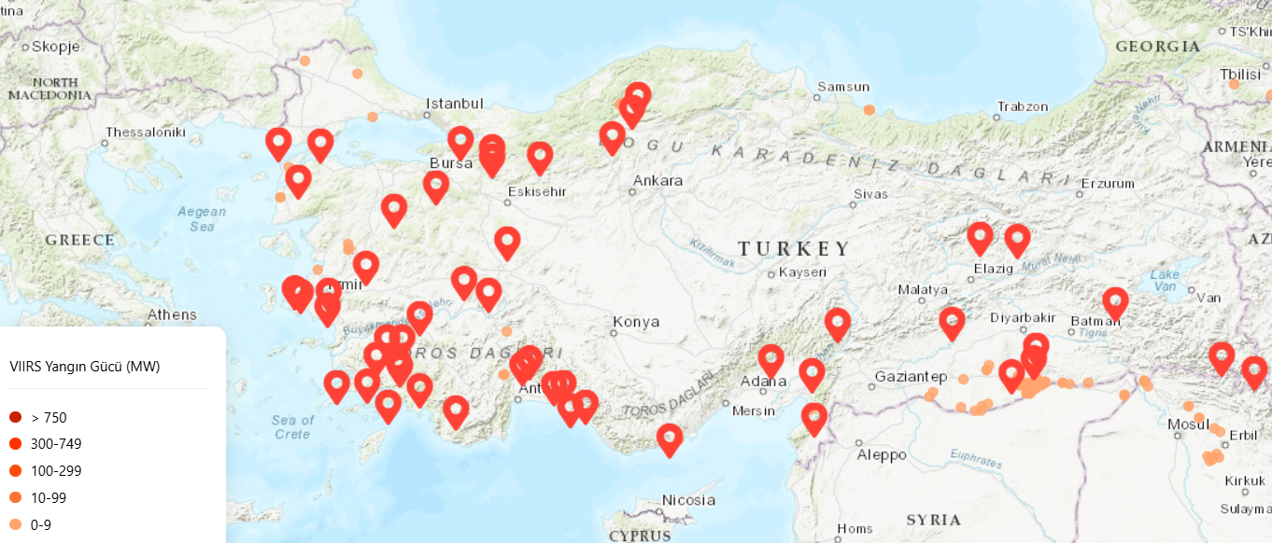
Figure 3: Map of Türkiye showing earthquake occurrence areas

2.5 Rainwater-Integrated Firefighting Water Tanks and Their Place in the Literature
Water supply is one of the most critical factors directly determining response capacity in forest fire management. In the literature, firefighting water tanks and replenishment points are generally considered as infrastructures dependent on existing surface water sources, reservoirs, or network systems. However, climate change, drought, and increasing fire frequency indicate that these traditional water sources may not always be sufficient or continuously available throughout the fire season [37].
In this context, rainwater harvesting offers an important approach that can be considered an alternative and complementary water source in firefighting. Although the rainwater harvesting literature mainly focuses on urban water management, agricultural irrigation, and rural water supply, studies integrating this approach with firefighting infrastructure remain limited [38]. This indicates that rainwater-integrated firefighting tanks represent an innovative solution area that has not been sufficiently addressed in the literature.
It is well known that in high fire-risk regions, precipitation is seasonally concentrated, whereas the fire season typically occurs during dry summer months. This seasonal mismatch reveals that rainwater collected during wet periods can be used as a strategic reserve for the fire season [39]. Rainwater-integrated tanks can enable water storage during the pre-fire preparation phase, providing rapid access to water during fire events.
The literature emphasizes that the success of early firefighting intervention is directly related to proximity to water sources and replenishment times. [40] demonstrates that the distance to water replenishment points plays a decisive role in controlling fires, particularly during the initial response phase. This finding highlights that rainwater-integrated tanks can play a significant role not only in sustainability but also in operational effectiveness.
In the water tank location literature, criteria such as accessibility, road networks, and fire risk are prominent. [30] emphasizes that fire risk maps and road network analyses should be evaluated together when locating firefighting water tanks in Mediterranean ecosystems. However, such studies generally treat the water source supplying the tanks as a fixed input and do not discuss in detail how water can be sustainably supplied.
In the rainwater harvesting literature, factors such as tank design, collectible rainfall volume, catchment surface, and tank capacity are identified as key determinants of system reliability [41]. When adapted to firefighting tanks, this approach enables the evaluation of whether tank capacity is sufficient not only for a single fire event but also for multiple fires or prolonged fire seasons.
In this study, an integrated tank planning approach is proposed by combining firefighting water infrastructure with rainwater harvesting systems, supporting both early intervention and continuity of water supply in high fire-risk regions. In this respect, the study treats firefighting water tanks not merely as passive infrastructure elements, but as active and sustainable water reserves fed by seasonal precipitation.
2.6 Comparative Evaluation of Water Tank Types for Firefighting Purposes
The design and selection of water supply infrastructure play a decisive role in combating wildfires in terms of response time, operational flexibility, and environmental impact. Water tanks used for firefighting are designed in different types depending on their structural characteristics and usage scenarios. In this study, three basic types of water tanks commonly used in firefighting are discussed; each type is evaluated from an operational and environmental perspective and compared in line with the objectives of the study.
The tank types examined within this scope are as follows:
- Open fire ponds,
- Underground or semi-buried water tanks, and
- Above-ground closed steel water tanks.
2.6.1 Open Fire Ponds
Open fire ponds are structures that generally spread over large areas and allow for the storage of large volumes of water. These types of reservoirs can be used as water intake points, especially in firefighting operations conducted with aerial vehicles. High-volume water storage capacity is considered the most significant advantage of open ponds.
However, open fire ponds have some major disadvantages. Due to their open surfaces, evaporation losses are high, and serious decreases in water levels can occur during hot and dry periods. Additionally, these structures can only be implemented in topographically limited areas due to their large land requirements. The environmental impacts of open ponds cannot be ignored either; the destruction of natural vegetation, disruption of ecosystem balance, and high maintenance requirements limit the use of such reservoirs.
For these reasons, while open fire ponds are suitable for large-scale and aerial-heavy intervention scenarios, they offer limited flexibility in terms of local and response-time-oriented fire intervention strategies.
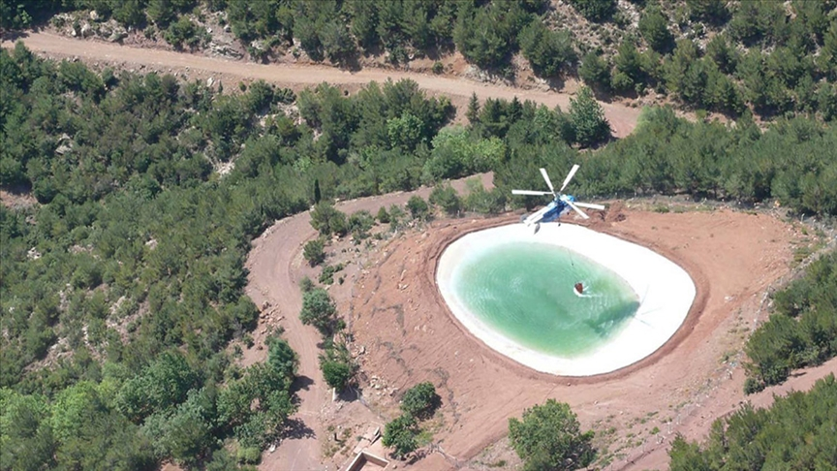

Figure 4. Representative image of an open water pond

2.6.2 Underground and Semi-Buried Water Tanks
Underground or semi-buried water tanks are among the preferred solutions due to providing minimum surface visibility and having relatively low environmental impacts. These tanks allow for the long-term preservation of water thanks to their low evaporation losses and protected structures against external factors.
However, the feasibility of these tank types is limited due to high construction costs and long installation times. The requirement for underground excavation carries the risk of damaging the soil structure and root systems in forested areas. Furthermore, increasing the capacity or relocating such tanks is quite difficult and costly compared to above-ground systems. In situations requiring rapid intervention, such as fires, the flexibility and scalability of these tanks remain limited.
Therefore, while underground and semi-buried tanks are suitable for permanent and fixed infrastructure solutions, they cannot provide sufficient operational flexibility for dynamic and risk-oriented fire intervention planning.
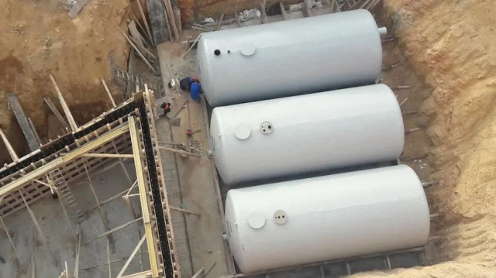

Figure 5: Representative image of an underground water storage tank used for water storage purposes

2.6.3 Above-Ground Closed Steel Water Tanks
Above-ground closed steel water tanks are among the prominent solutions in water supply infrastructure for firefighting, thanks to their modular structures, short installation times, and high durability features. These tanks can be designed according to different capacity needs, and their capacity can be easily expanded when necessary.
Due to their closed structure, evaporation losses are at a minimum, and the stored water maintains its usability throughout the fire season. Being above-ground facilitates maintenance and inspection processes; at the same time, positioning them near the road network allows ground response teams to perform rapid water replenishment.
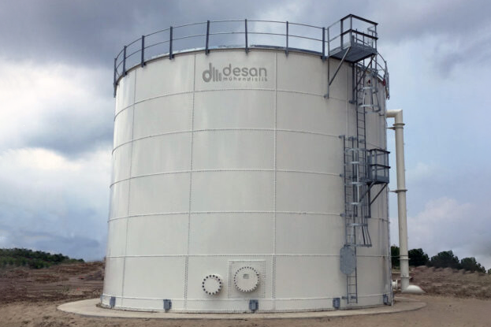
This type of tank is also suitable for integration with rainwater harvesting systems. Storing water collected during rainy periods creates a reliable water source during dry periods when fire risk is high and reduces the need for water transportation from external sources. Furthermore, the fact that extensive excavation work is not required during the field application of these tanks ensures that environmental impacts remain limited.
Figure 6: Representative image of a closed water storage tank used in the model
As a result of the evaluation, although open fire ponds and underground water tanks offer advantages under certain conditions, they do not fully align with the objectives of this study in terms of land requirements, environmental impact, installation time, and operational flexibility. In contrast, above-ground closed steel water tanks provide an infrastructure solution that can be installed rapidly, offers scalable capacity, has limited environmental impact, and is specifically designed to reduce response times.
Therefore, above-ground closed steel water tanks have been taken as the basis for the mathematical model and field application scenarios of this study. The selected tank type has been evaluated as the most suitable solution in line with the goals of minimizing response time, increasing accessibility, and ensuring sustainable water supply.

 | MATHEMICAL MODEL | WATER TANK LOCATION DECISION | TERRAIN INFRASTRUCTURE | RAINWATER HARVESTING
Clarke & Wright (1964) | ✓ | ✗ | ✗ | ✗
Akay et al. (2011) | ✗ | ✗ | ✓ | ✗
Renkas (2022) | ✓ | ✗ | ✓ | ✗
Holuša et al. (2021) | ✗ | ✗ | ✓ | ✗
Proposed Model | ✓ | ✓ | ✓ | ✓

Table 2: Comparison of the proposed model with selected studies from the literature

Problem Definition
Forest fires pose serious environmental and economic risks, particularly due to climate change and increasing drought conditions. Effective and timely fire response depends on delivering sufficient water to response points quickly and sustainably. Therefore, proper planning of water supply infrastructure in fire-prone areas is critical. This study addresses the problem of establishing rainwater harvesting integrated reservoirs in suitable locations, with appropriate capacity and cost, to meet the water needs of fire response points. The problem is considered by taking into account multiple demand (risk) points, multiple candidate reservoir locations, and different reservoir types (small, medium, large) that can be established at each location. Each demand point must be assigned to at least one reservoir accessible within the determined maximum acceptable response time. At the same time, the total amount of water required by the demand points must be fully met by water supplied from one or more reservoirs. The water source for the reservoirs consists of the annual water amount obtained through rainwater harvesting at candidate locations and supplementary water transported from external sources when necessary. The problem definition considers not only operational requirements but also site suitability conditions. Candidate depot locations must meet physical and environmental criteria such as slope, distance from settlements, and conservation status. Depot construction is not permitted in areas that do not meet these conditions. Furthermore, each depot must serve at least a certain number of demand points. This approach aims to prevent operationally inefficient depot solutions with low utilization rates. Only one type of depot can be established at each candidate location. The primary objective within this problem is to minimize the total system cost by considering depot opening costs, operating costs depending on the depot type, and the cost of water transported from external sources.

Mathematical Model For The Problem
Component Type | Symbol | Definition
Set | $$I$$ | Demand / risk points (fire response points)
Set | $$J$$ | Candidate watertank locations
Set | $$K$$ | Water Tank types k=small(1), medium(2), large(3)
Parameter | $$t_{ij}$$ | The travel time from water tank j to demand point i
Parameter | $$T_{i}$$ | Maximum acceptable response time for the point of demand.
Parameter | $$a_{ij}$$ | Accessibility (coverage) parameter
Parameter | $$d_{i}$$ | Water requirement of demand point i (m³)
Parameter | $$P_{j}$$ | Annual rainfall at candidate location j
Parameter | $$A_{j}$$ | Water collection / roof surface area
Parameter | $$ϕ_{j}$$ | Runoff coefficient
Parameter | $$η_{j}$$ | System efficiency
Parameter | $C_{k}$ | Capacity of water tank type 𝒌 (m³).
Parameter | $$F_{k}$$ | Fixed opening cost of water tank type k
Parameter  Parameter  Parameter  Parameter  Parameter  Parameter | $$O_{k}$$  $$u_{j}$$  $$S_{j}$$  $$S_{max}$$  $$M_{j}$$  $$M_{min}$$ | Annual operating cost of water tank type k  Is the candidate location under protection? (1,0)  Slope percentage of the candidate storage point  Maximum slope at which the water tank can be opened  Distance of the candidate water tank location from the nearest settlement  Specified minimum safety distance
Parameter | $$c_{ext}$$ | Unit cost of water transported from outside
Decision Variable | $$x_{jk}$$ | If type k is opened in water tank j, then 1
Decision Variable | $$y_{ij}$$ | If demand point i is assigned to water tank j, then 1
Decision Variable | $$w_{j}$$ | The mount of water transported from an external source to water tank j
Decision Variable | $$q_{ij}$$ | The amount of water sent from water tank j to demand point
$$a_{ij}=\left\{\begin{matrix}1, & t_{ij}≤T_{i} \\ 0, & otherwise\end{matrix}\right.$$
$$C_{k}=R_{j}x_{jk}+w_{j}$$
$$u_{j}∈\{0,1\}$$
$$x_{jk}∈\{0,1\}$$
$$y_{ij}∈\{0,1\}$$

Objective Function:
$$min Z=\sum_{j∈J}{\sum_{k∈K}{F_{k}x_{jk}}}+\sum_{j∈J}{\sum_{k∈K}{O_{k}x_{jk}}}+c_{\text{ext}}\sum_{j∈J}{w_{j}} 1$$

Subject To:
$$y_{ij}≤a_{ij}\sum_{k∈K}{x_{jk} }∀i,j 2$$
$$\sum_{j∈J}{y_{ij}}≥1 ∀i∈I 3$$
$$\sum_{j∈J}{q_{ij}}≥d_{i} ∀i∈I 4$$
$$q_{ij}≤d_{i} y_{ij} ∀i∈I, ∀j∈J 5$$
$$\sum_{i∈I}{q_{ij}}≤\sum_{k∈K}{C_{k}}x_{jk} ∀j 6$$
$$\sum_{k∈K}{x_{jk}}≤1 ∀j 7$$

$$\sum_{k∈K}{x_{jk}}≤1-u_{j} ∀j∈J 8$$
$$x_{jk}=0∀j∈J \text{such} \text{that} S_{j}>S_{max}, ∀k∈K 9$$
$$xjk​=0∀j∈J such that M_{j}​<M_{min}​,∀k∈K 10$$

Objective Function

(1) The first term of the objective function
$$\sum_{j∈J}{\sum_{k∈K}{F_{k}}} x_{jk}$$
The candidate location j represents the fixed water tank opening cost incurred if the water tank type is not selected. This cost is only considered if a water tank is opened at that location.
Second Term,
$$\sum_{j∈J}{\sum_{k∈K}{O_{k}}} x_{jk}$$
These represent the annual operating costs of the opened water tank. These costs, which vary depending on the type and number of water tanks, have been included in the model to ensure the continuity of the system.
Third term,
$$c_{ext}\sum_{j∈J}{w_{j}}$$
This refers to the cost of transporting water from external sources to reservoirs. In situations where rainwater harvesting is insufficient, this term represents the total cost of externally supplied water.
Constraints:
(2): Eq. (2) represents that a demand point can only be assigned to a water tank that is both accessible within the predefined response time and officially opened in the system. This constraint ensures that assignments are made exclusively to feasible water tanks that satisfy accessibility and operational availability conditions.
(3): Eq. (3) ensures that each demand point is assigned to at least one water tank. This constraint guarantees full coverage of all demand points and prevents the existence of any fire response point without access to a water supply source.

(4): Eq. (4) states that the water demand of each demand point must be fully satisfied by the total amount of water supplied from the assigned water tanks. This constraint enforces demand fulfillment and ensures that firefighting operations receive sufficient water for effective intervention.
(5): Eq. (5) ensures that water cannot be transported from a water tank to a demand point unless an assignment exists between them. This constraint maintains logical consistency between assignment decisions and water flow decisions by preventing unnecessary or infeasible water transfers.
(6): Eq. (6) ensures that the total amount of water withdrawn from a water tank does not exceed its storage capacity. This constraint reflects the physical limitation of the tank and guarantees that operational decisions remain within feasible capacity limits.
(7): Eq. (7) enforces that only a single type of water tank can be established at each candidate water tank location. This constraint avoids multiple tank installations at the same location and ensures a clear and unambiguous infrastructure decision for each site.
(8): Eq. (8) ensures that a water tank can only be opened at a candidate location if the area is not under environmental or legal protection. This constraint incorporates environmental conservation regulations into the model and prevents infrastructure development in protected areas.
(9): Eq. (9) states that the slope percentage of a candidate water tank location must be below the specified maximum allowable slope value. This constraint ensures the physical feasibility and construction suitability of the selected locations.
(10): Eq. (10) ensures that the distance between a candidate water tank location and the nearest settlement is greater than the predefined minimum safety distance. This constraint addresses safety concerns and minimizes potential risks to residential areas during firefighting operations.

CONCLUSION
This study develops a mathematical model to determine the optimal placement of water tanks integrated with rainwater harvesting, aiming to reduce response time in combating forest fires and make water supply processes more efficient and sustainable. Given the increasing frequency and intensity of forest fires, the critical importance of early and effective fire response is clearly evident. In this context, infrastructure planning that provides rapid access to water while considering environmental and logistical constraints has become a fundamental need in fire management. In the developed model, water tanks are treated as direct decision variables; numerous geographical and environmental constraints such as the coverage of high-risk demand points, maximum acceptable response time, tank capacity, road accessibility, slope, distance from settlements, and protection status are evaluated simultaneously. Furthermore, by limiting the number of tank types to only one per candidate location and requiring each tank to serve a specific number of demand points, the model aims to prevent operationally inefficient solutions. One of the most important innovations of the model is the integration of rainwater harvesting into the water supply infrastructure. This ensures that rainwater collected throughout the year forms a usable reserve for the fire season; the amount of water transported from external sources and the associated costs are significantly reduced. This approach not only contributes to cost minimization but also allows for the creation of a closed water loop that supports environmental sustainability. In this study, different water tank types were compared, and based on criteria such as environmental impact, installation time, capacity flexibility, and operational efficiency, above-ground closed steel water tanks were deemed suitable as the basic tank type in the model. The modular structure of these tanks, their low evaporation losses, and their compatibility with rainwater harvesting offer a fast and reliable solution in fire fighting. The results show that the proposed model can provide a scientific and systematic decision support tool for decision-makers in forest fire response processes. The model has the potential to produce concrete outputs for the planning of water supply infrastructure, especially in high-risk fire areas such as Turkey's Mediterranean and Aegean regions. In the long term, integrating this approach into national disaster management policies will contribute to increasing resilience to fires and managing natural resources more sustainably. In conclusion, this thesis offers a holistic and innovative perspective on water supply infrastructure in combating forest fires by combining engineering-based optimization methods with geographical and environmental constraints. The developed model provides an original contribution to the academic literature and serves as a guide for public institutions and local governments in terms of practical application.
Future Goals
This study develops a mathematical model for the optimal positioning of water reservoirs integrated with rainwater harvesting to support forest fire response processes. The second phase, a continuation of this study, aims to make the model more concrete, realistic, and application-oriented. In the second phase, real data from forest fires in Turkey in previous years will be examined in detail. The model will be supported by real data, analyzing the spatial distribution of fires, the size of affected areas, response times, and extinguishing processes. Focusing particularly on high-risk fire areas such as the Mediterranean and Aegean regions, the model will be made to produce more realistic results for these areas. In this way, the study will move beyond being merely a theoretical model and become a concrete decision support tool for application. Furthermore, the integration of the developed mathematical model with Geographic Information Systems (GIS) will be strengthened in the second phase. Spatial data related to road networks, land slope, accessibility, vegetation, and land use will be included in the model to ensure more precise and realistic determination of water reservoir locations. Finally, by analyzing model solutions under different investment and budget scenarios, feasible policy recommendations will be developed for public institutions and local governments. Thus, this study aims not only to provide an academic contribution but also to present a practical and sustainable decision support system that can be used in combating forest fires in Turkey. In summary, in the second phase, by using real fire data, expanding the model constraints, and deepening spatial analyses, this study will be transformed into a more concrete, applicable, and guiding structure for decision-makers.

REFERENCES
[1] Bonan, G. B. (2008). Forests and climate change: Forcings, feedbacks, and the climate benefits of forests. Science, 320(5882), 1444–1449.
[2] FAO. (2022). The State of the World’s Forests 2022. Rome: Food and Agriculture Organization of the United Nations.
[3] Costanza, R., de Groot, R., Sutton, P., van der Ploeg, S., Anderson, S. J., Kubiszewski, I., … Turner, R. K. (2014). Changes in the global value of ecosystem services. Nature Climate Change, 4(2), 152–158.
[4] Avcı, M., & Korkmaz, M. (2021). Türkiye’de orman yangınlarının mekânsal ve zamansal analizi. Türk Coğrafya Dergisi, 76, 1–15.
[5] Pausas, J. G., & Keeley, J. E. (2021). Wildfires and global change. Nature Reviews Earth & Environment, 2(7), 529–544.
[6] OGM. (2024). Orman Yangınları İstatistikleri ve Faaliyet Raporu. Ankara: Orman Genel Müdürlüğü.
[7] AFAD. (2024). Türkiye Afet Yönetimi ve Orman Yangınları Raporu. Ankara: Afet ve Acil Durum Yönetimi Başkanlığı.
[8] Ayanoğlu, S., Dölarslan, E. S., & Gül, A. U. (2017). Orman yangınlarının ekolojik ve sosyoekonomik etkileri. Ormancılık Araştırma Dergisi, 2, 45–58.
[9] Martell, D. L. (2001). A review of recent forest fire management decision support systems. Canadian Journal of Forest Research, 31(4), 593–603.
[10] Thompson, M. P., Calkin, D. E., Finney, M. A., Gebert, K. M., & Hand, M. S. (2013). Risk-based wildfire management. Forest Ecology and Management, 294, 1–9.
[11] Radeloff, V. C., Helmers, D. P., Kramer, H. A., Mockrin, M. H., Alexandre, P. M., Bar-Massada, A., … Hawbaker, T. J. (2018). Rapid growth of the US wildland–urban interface. Proceedings of the National Academy of Sciences, 115(13), 3314–3319.
[12] OGM. (2023). Yangınla Mücadele Faaliyetleri Değerlendirme Raporu. Ankara: Orman Genel Müdürlüğü.
[13] Haight, R. G., & Fried, J. S. (2007). Deploying wildfire suppression resources with a scenario-based standard response model. International Journal of Wildland Fire, 16(1), 31–39.
[14] Renkas, J. (2022). Optimization models for wildfire response and resource allocation. Computers & Operations Research, 145, 105849.
[15] Akay, A. E., Erdaş, O., Reis, M., & Yıldırım, İ. C. (2011). GIS-based forest road network analysis. African Journal of Biotechnology, 10(75), 17004–17015.
[16] Akay, A. E., Wing, M. G., & Sessions, J. (2020). Estimating wildfire suppression access using GIS-based network analysis. Forest Policy and Economics, 118, 102229.
[17] Thompson, M. P., Riley, K. L., Loeffler, D., & Haas, J. R. (2014). Modeling wildfire suppression resource use and tradeoffs. International Journal of Wildland Fire, 23(6), 863–875.
[18] USFS. (2019). Large Airtanker Modernization Strategy. Washington, DC: U.S. Forest Service.
[19] Holuša, J. (2021). Forest fire risk assessment and management approaches. Fire, 4(3), 45.
[20] Martínez, J., López, R., & García, M. (2024). Strategic location of water reservoirs for wildfire suppression using coverage-based models. International Journal of Wildland Fire, 33(2), 145–158.
[21] Lopes, A., Ferreira, J., & Santos, R. (2024). Multi-criteria decision support for sustainable wildfire prevention planning in Mediterranean forests. Forest Policy and Economics, 156, 103045.
[22] Ha, J., Finney, M. A., & Calkin, D. E. (2018). The operational role of water supply points in wildfire suppression modeling. Fire Safety Journal, 95, 80–89.
[23] Wei, Y., Bevers, M., & Belval, E. (2019). Spatial optimization of wildfire suppression resource allocation under response time constraints. European Journal of Operational Research, 276(3), 1026–1038.
[24] Rodríguez y Silva, F., Molina, J. R., & González-Cabán, A. (2020). Simulation-based evaluation of wildfire station location and suppression performance. Simulation Modelling Practice and Theory, 100, 102032.
[25] Forest fire resource planning with integer programming. (2025). Computers & Operations Research, 161, 106423.
[26] Belongia, S., Bladon, K. D., & Emelko, M. B. (2023). Cascading impacts of wildfires on drinking water systems. Environmental Research Letters, 18(4), 045006.
[27] Kalapodis, P., Panteli, M., & Mancarella, P. (2025). Infrastructure interdependencies and resilience under wildfire hazards. Reliability Engineering & System Safety, 242, 109714.
[28] Arango, E., Murray, A. T., & Tong, D. (2025). Transportation network vulnerability and recovery after wildfire events. Transportation Research Part A: Policy and Practice, 178, 103842.
[29] Murray, A. T. (2013). Optimizing the spatial location of emergency service facilities with backup coverage. Computers & Operations Research, 40(11), 2805–2814.
[30] Arabatzis, G., Karanikola, P., & Tsiantikoudis, S. (2024). Locating wildfire water reservoirs under accessibility and sustainability constraints. Sustainability, 16(3), 1187.
[31] Memişoğlu Baykal, E., Şen, O. L., & Türkeş, M. (2023). Spatial and temporal patterns of forest fires in Türkiye. Natural Hazards, 117(2), 1489–1512.
[32] Çolak, E. (2020). Spatial analysis of forest fire occurrence in Mediterranean regions of Türkiye. Applied Geography, 119, 102221.
[33] Akay, A. E., & Şahin, M. (2019). Fire risk mapping using GIS-based multi-criteria analysis in Mediterranean forests. Environmental Monitoring and Assessment, 191(5), 310.
[33] Özşahin, E. (2018). Topographic effects on forest fire behavior in western Türkiye. Journal of Environmental Biology, 39(6), 1037–1045.
[35] Sivrikaya, F. (2024). Forest fire susceptibility mapping using NDVI and soil moisture indices. Remote Sensing Applications: Society and Environment, 33, 101057.
[36] Özcan, O., Yıldırım, İ. C., & Akay, A. E. (2025). Integrated wildfire risk assessment considering soil, water, vegetation and human activities. Ecological Indicators, 158, 110341.
[37] Turco, M., Bedia, J., Di Liberto, F., Fiorucci, P., Von Hardenberg, J., Koutsias, N., … Provenzale, A. (2017). Decreasing fires in Mediterranean Europe. Nature Communications, 8, 13728.
[38] Vaz, A. S., Kueffer, C., Kull, C. A., Richardson, D. M., Schindler, S., Muñoz-Pajares, A. J., … Vicente, J. R. (2023). Rainwater harvesting as a climate adaptation strategy. Science of the Total Environment, 858, 159745.
[39] Kum, D. (2016). Rainwater harvesting potential for seasonal water storage. Water Resources Management, 30(11), 3907–3922.
[40] Garcia-Chevesich, P., Fuster, R., & McCray, J. E. (2015). Water supply distance effects on wildfire suppression efficiency. Journal of Environmental Management, 159, 219–226.
[41] Ross, J., Pomeroy, C., & Rowe, A. (2022). Reliability assessment of rainwater harvesting systems. Journal of Cleaner Production, 357, 131899.

